**Task 1:**

#include <iostream>

#include<math.h>

using namespace std;

int main(){

float a;

float b;

cout<< " kindly insert the value of a"<<endl;

cout<< "a=";

cin>>a;

cout<<endl;

cout<< " kindly insert the value of b"<<endl;

cout<<"b=";

cin>>b;

cout<<endl;

cout<<" Answer of a2 + b2+ 2ab = ";

cout<< pow(a,2) +2*a*b + pow(b,2);

return 0;}

**Output of the code:**

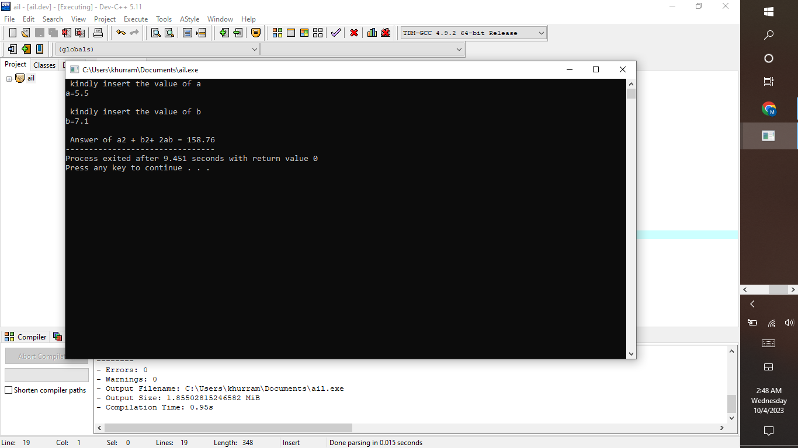

**Task 2:**

#include <iostream>

#include <math.h>

using namespace std;

int main(){

float a,b=1,x;

cout<< " find the factorial of: ";

cin>> x;

cout<< " Answer=";

for ( a=1; a<=x; a++)

{

b = b*a ;

}

cout<<b;

return 0;}

**Output of the code:**

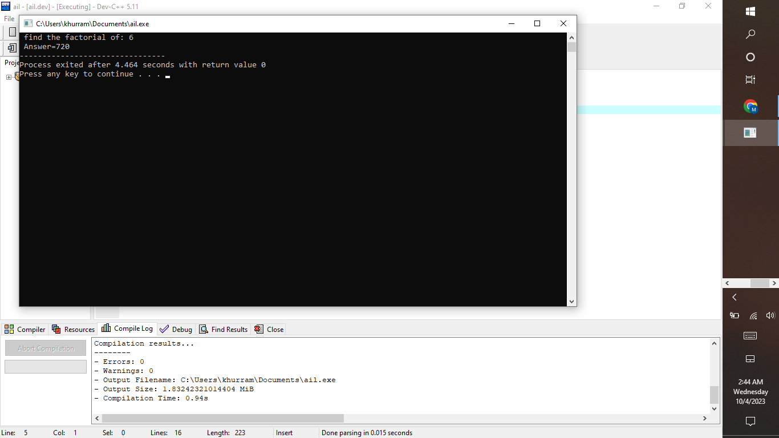

**Task 3:**

#include<iostream>

#include<math.h>

using namespace std:

int main(){

float x1;

float y1;

float x2;

float y2;

cout<< " insert the coordinates of 1st point"<<endl;

cout<<endl;

cout<< " x1=";

cin>> x1;

cout<< endl;

cout<< " y1=";

cin>> y1;

cout<< endl;

cout<< " insert the coordinates of 2nd point"<<endl;

cout<< " x2=";

cin>>x2;

cout<< endl;

cout<<" y2=";

cin>> y2;

cout<< "distance between two points= ";

cout<< sqrt(pow(x2-x1,2)+pow( y2-y1,2));

return 0;

}

**Output of the code:**

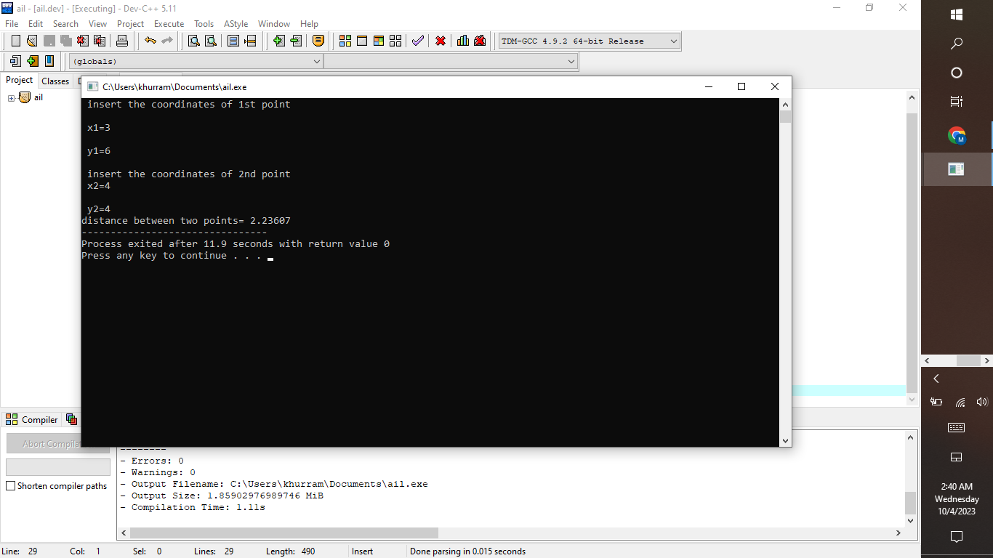

**Task 4:**

#include <iostream>

#include<math.h>

using namespace std;

int main(){

float a;

cout<<"value in centimeters = ";

cin>>a;

cout<<endl;

cout<< "value in meters= "<< a/100;

cout<<endl<<endl;

cout<< "value in kilometers="<<a/100000;

return 0;

}

**Output of the code:**

